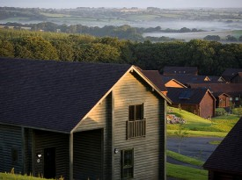

**Bluestone National Park Resort – 115 Timber Lodges**

**Design, manufacture and erection of 115 new Timber Lodges across two phases. Constructed in 2011 the first phase consisted of 65 lodges followed by the second phase of 50 constructed in 2015. Seven Oaks provided the timber frame superstructures, floor cassettes , timber cladding and timber roof shingles on all 115 lodges. The timber cladding was pre–installed on each panel in the factory which negated the need for follow on trades and provided a programme and cost saving to the client. The lodges are finished to a high specification to meet the resort’s 5 star credentials.**

**Type of Project - Commercial**

**Client - Bluestone National Park Resort**